**Use case:**

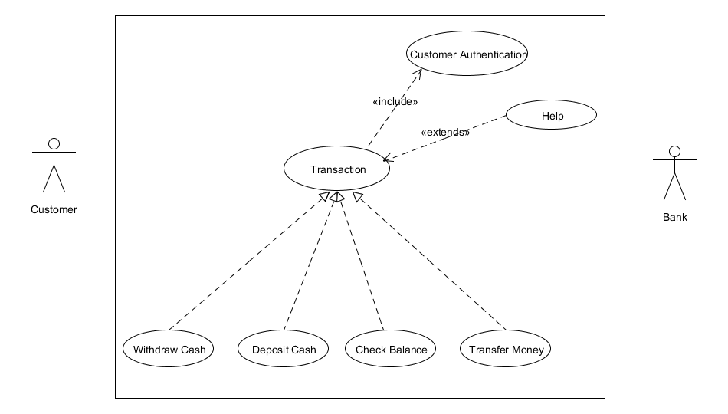

**Use case Scenario:**

**Name:** Withdraw Cash

**Brief Description:** The customer withdraw cash from ATM.

**Actors:** Customer, Bank

**Preconditions:**

Network connection is established.

ATM has available cash.

Customer has ATM card.

**Basic Flow:**

Customer insert ATM card. The system read it and prompts for PIN.

The customer enters PIN. The system validates PIN.

ATM displays actions available on ATM unit. Customer selects Withdraw Cash.

ATM request account type.

Customer select account type.

ATM request amount.

Customer enter amount.

Information sent to Bank to validate the availability of requested amount

System asks the customer to withdraw the card. Customer withdraws the card.

ATM dispenses the requested amount of cash and prints receipt.

**Alternate Flow:**

Customer is not validated

ATM displays error message

Customer selects invalid amount.

ATM prompts user to re-enter valid amount.

Customer has insufficient balance

ATM shows error message.

ATM shows available withdrawal limit.

ATM has insufficient cash.

ATM Technician is alerted.

ATM displays error message and phone number to call.

Cash gets stuck in dispensing.

ATM displays error message.

**Use case:**

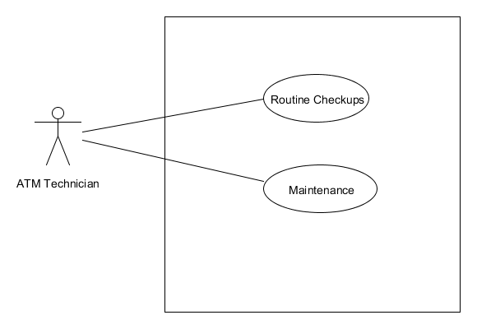

**Use case Scenario:**

**Name:** Withdraw Cash

**Brief Description:** The Technician will do ATM maintenance.

**Actors:** ATM Technician

**Preconditions:**

No Customer is using ATM.

**Basic Flow:**

Technician will turn the ATM switch to ‘off’ position.

Connection to bank will be shutdown.

Technician will perform maintenance task.

Technician will turn the ATM switch to ‘on’ position.

Connection to bank will be established.

**Test case: 1**

**Title:** Customer Authentication

**Description:**

The authorized user will be successfully login to their account.

**Test steps:**

Insert ATM card.

Enter PIN code.

Press Enter.

**Expected Result**

ATM will show available actions on ATM unit.

**Test case: 2**

**Title:** Insufficient ATM cash

**Description:**

When customer request amount for withdraw and ATM has not enough cash available.

Precondition: Customer is already login.

**Test steps:**

Select Withdraw cash option.

Select account type.

Enter amount

Press Enter.

**Expected Result**

ATM will show error with message of ‘Insufficient amount’

**Test case: 3**

**Title:** Insufficient Customer cash

**Description:**

When customer request more amount to withdraw then available balance in account.

Precondition: Customer is already login.

**Test steps:**

Select Withdraw cash option.

Select account type.

Enter amount

Press Enter.

**Expected Result**

ATM will show error with message of “Your account balance is insufficient”

ATM will show available amount and request to again enter amount.

**Test case: 4**

**Title:** Balance status

**Description:**

When customer want to check his account balance.

Precondition: Customer is already login.

**Test steps:**

Select Check Balance option.

Press Enter.

**Expected Result**

ATM will show account status.